Exploratory Data Analysis

1. FRA purchase on a growing trend (at least production region with no millers)

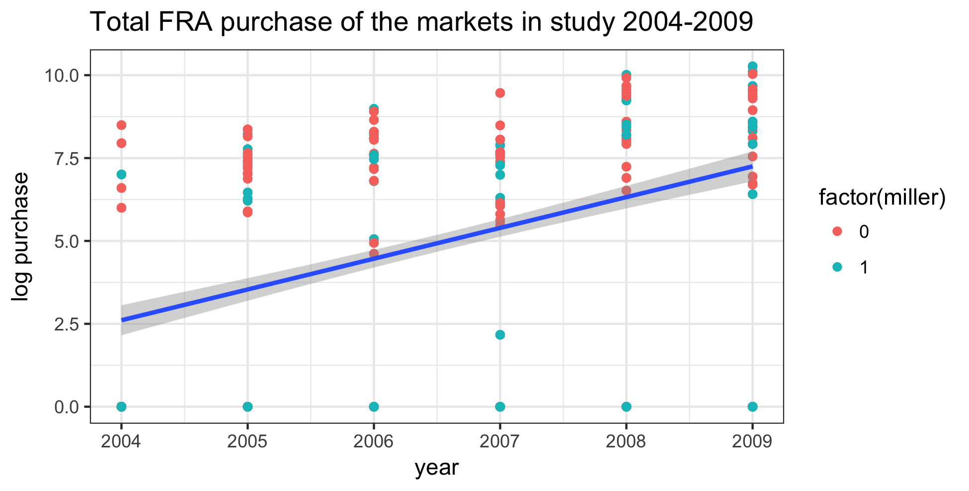

1. The sum of FRA purchase in local markets in the previous year associated with a lower price in the next year during lean season

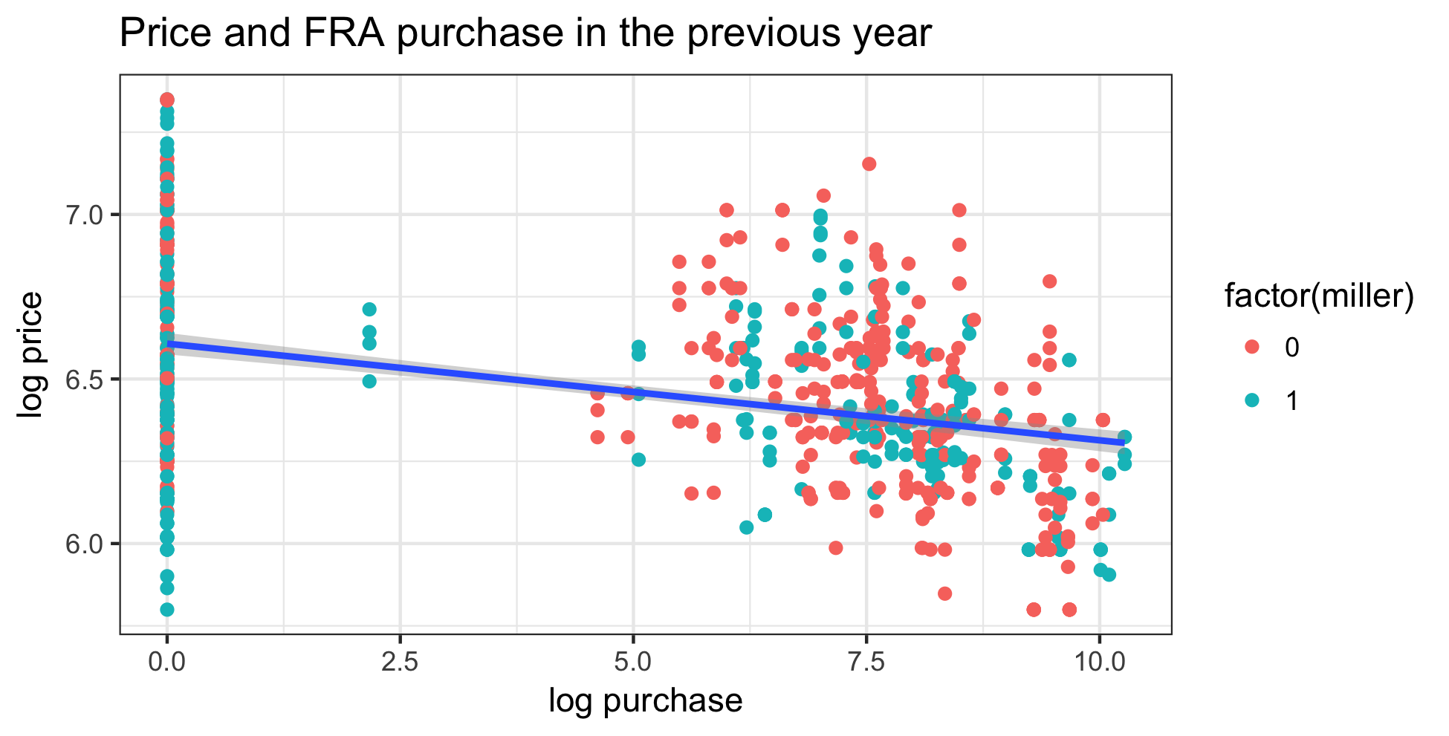

1. Miller district vs not

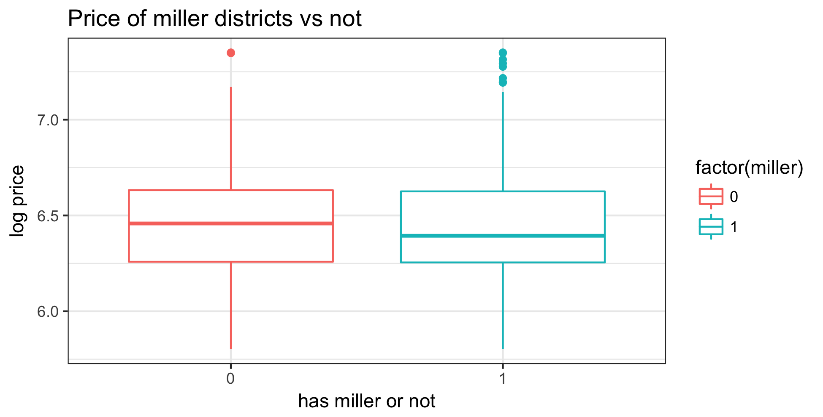

1. FRA sales and price reflects that the FRA sells more maize in month when the price is higher ( reverse causality)

